Lab 5: DHCP, RIP Routing, and Web/Email Server Configuration in Cisco Packet Tracer

Objective:
To configure DHCP-based automatic addressing and RIP dynamic routing between two routers, and to deploy, configure, and test Web (HTTP/DNS) and Email (SMTP/POP3) server services in Cisco Packet Tracer, verifying end-to-end connectivity and application-level functionality using both real-time and simulation modes.

Theory:
A router-to-router network becomes functional when its end devices can communicate with one another and access the services provided within the network. This lab integrates three components that were previously configured separately: automatic IP address allocation using DHCP, dynamic route discovery using RIP, and two application-layer services—a web server and a mail server—that operate over the established routed network.

Dynamic Host Configuration Protocol (DHCP)
Instead of manually assigning a static IP address to each PC or laptop on a LAN, DHCP automatically provides the necessary network configuration through a router or server. A DHCP pool specifies the range of IP addresses available for assignment, along with the default gateway and DNS server information. When a client starts and requests network access, the DHCP server assigns an available address from the pool and provides the required configuration details. Therefore, all end devices in this lab are configured to obtain their IP addresses automatically using “DHCP” rather than through manual assignment.

Routing Information Protocol (RIP)
RIP is a distance-vector routing protocol in which each router learns routing information from its directly connected neighboring routers. It determines the best route based on the number of hops, with the path requiring the fewest hops being preferred. After enabling RIP version 2 and advertising the networks directly connected to each router, the routers periodically exchange routing information. This allows them to automatically discover routes to remote LANs without requiring manually configured static routes.

Domain Name System (DNS) and HTTP
DNS translates human-readable domain names, such as sxc.edu.np, into the IP addresses of the servers hosting the requested resources. This allows users to access websites using a domain name instead of entering a numerical IP address. After enabling the DNS service and configuring the appropriate resource record, the HTTP service on the web server delivers the stored HTML page whenever a client requests the domain. This enables devices on both LANs to verify network connectivity by accessing the website through its domain name.

Email Services: SMTP and POP3
SMTP (Simple Mail Transfer Protocol) is responsible for sending outgoing emails, while POP3 (Post Office Protocol version 3) is used to retrieve incoming messages. Both services can operate on the same server under a common domain name, with separate user accounts configured for individual mailboxes. Each client’s email application is configured to use the domain as both the incoming and outgoing mail server. This allows users on different LANs to send, receive, and reply to emails through the routed network.
Addressing Plan:
Router | Interface | Connected To | IP Address | Subnet Mask
SiddhantR0 | GigabitEthernet0/0 | SiddhantR1 G0/0 | 172.16.1.1 | 255.255.255.252
SiddhantR0 | GigabitEthernet0/1 | Switch0 (LAN1) | 192.168.1.1 | 255.255.255.0
SiddhantR1 | GigabitEthernet0/0 | SiddhantR0 G0/0 | 172.16.1.2 | 255.255.255.252
SiddhantR1 | GigabitEthernet0/1 | Switch1 (LAN2) | 192.168.2.1 | 255.255.255.0

End Devices:
Device | Connected Switch | IP Address (DHCP) | Default Gateway
PC0 | Switch0 | 192.168.1.2 | 192.168.1.1
Laptop0 | Switch0 | 192.168.1.3 | 192.168.1.1
PC1 | Switch1 | 192.168.2.2 | 192.168.2.1
Laptop1 | Switch1 | 192.168.2.3 | 192.168.2.1

Server Configuration:
Parameter | Value
Hostname | Server0
Connected To | Switch0 (LAN1)
IPv4 Address | 192.168.1.100
Subnet Mask | 255.255.255.0
Default Gateway | 192.168.1.1
DNS Server | 192.168.1.100 (self)
Domain Name | sxc.edu.np

Components Required:
- 2 Routers (2901)
- 2 Switches (2960)
- 4 End devices (2 PCs and 2 Laptops)
- 1 Server (Server-PT) for DNS, HTTP, and Email services
- Copper cross-over cable (router-to-router link)
- Copper straight-through cables (switch-to-router, switch-to-end-device, and switch-to-server links)

Procedure:

1) Build the topology
- Place two routers (2901), SiddhantR0 and SiddhantR1, and connect them directly using a copper cross-over cable.
- Add one switch (2960) to each router: Switch0 to SiddhantR0 and Switch1 to SiddhantR1, using straight-through cables.
- Attach one PC and one Laptop to each switch, also via straight-through cable, and connect a server (Server0) to Switch0 to host the DNS, web, and email services.

Output:
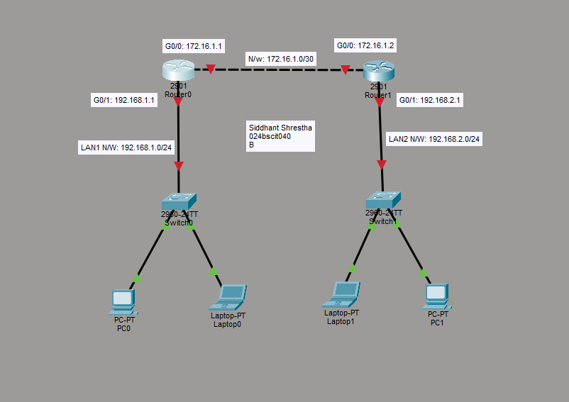

2) Configure Router0’s interfaces
Open Prince_R1's CLI, set a hostname, and bring up the link toward SiddhantR0:
Router>en
Router#conf t
Router(config)#hostname SiddhantR0
SiddhantR0(config)#interface GigabitEthernet 0/0
SiddhantR0(config-if)#ip address 172.16.1.1 255.255.255.252
SiddhantR0(config-if)#no shutdown

Configure the LAN-facing interface toward Switch0:
SiddhantR0(config-if)#exit
SiddhantR0(config)#interface GigabitEthernet 0/1
SiddhantR0(config-if)#ip address 192.168.1.1 255.255.255.0
SiddhantR0(config-if)#no shutdown
SiddhantR0(config-if)#exit

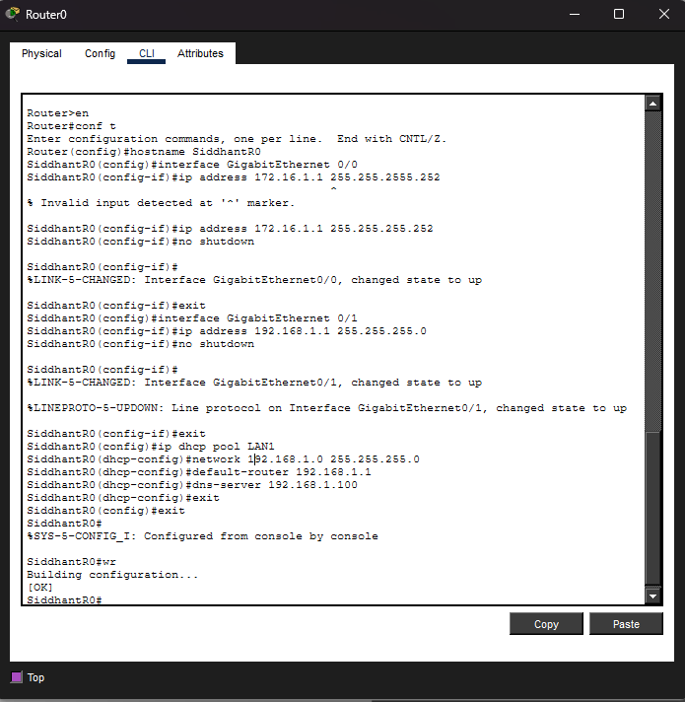
Output:

3) Create Router0’s DHCP pool
Still in global configuration mode, set up a DHCP pool for the LAN1 subnet, including the default gateway and DNS server, then save the configuration:
SiddhantR0(config)#ip dhcp pool LAN1
SiddhantR0(dhcp-config)#network 192.168.1.0 255.255.255.0
SiddhantR0(dhcp-config)#default-router 192.168.1.1
SiddhantR0(dhcp-config)#dns-server 192.168.1.100
SiddhantR0(dhcp-config)#exit
SiddhantR0(config)#exit
SiddhantR0#wr

Output:

4) Enable RIP on Router0
Enter router configuration mode for RIP, set version 2, and advertise every network directly connected to SiddhantR0:
SiddhantR0#conf t
SiddhantR0(config)#router rip
SiddhantR0(config-router)#version 2
SiddhantR0(config-router)#network 172.16.1.0
SiddhantR0(config-router)#network 192.168.1.0
SiddhantR0(config-router)#exit
SiddhantR0(config)#exit
SiddhantR0#wr

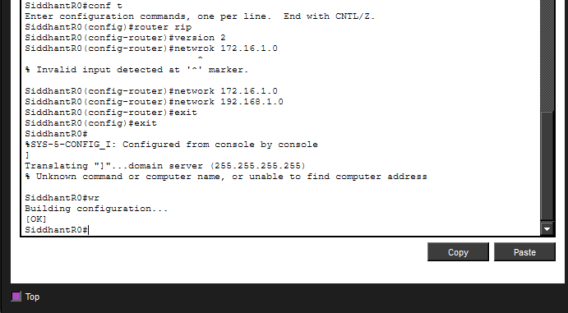
Output:

5) Verify DHCP is reaching PC0 and Laptop0
Open PC0 and Laptop0, go to Desktop → IP Configuration, select DHCP, and confirm each device automatically receives an address, subnet mask, gateway, and DNS server from the 192.168.1.0/24 pool.

Output:
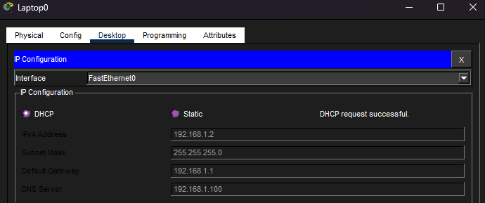
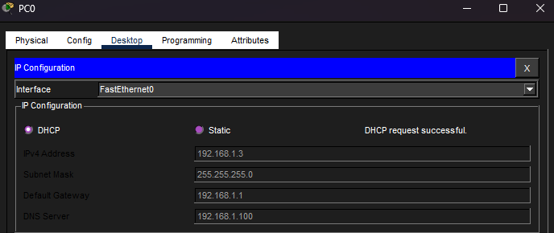

6) Configure Router1's interfaces
Open SiddhantR1's CLI, set a hostname, and configure both the link toward SiddhantR0 and the LAN-facing interface toward Switch1:
Router>en
Router#conf t
Router(config)#hostname SiddhantR1
SiddhantR1(config)#interface GigabitEthernet 0/0
SiddhantR1(config-if)#ip address 172.16.1.2 255.255.255.252
SiddhantR1(config-if)#no shutdown
SiddhantR1(config-if)#exit
SiddhantR1(config)#interface GigabitEthernet 0/1
SiddhantR1(config-if)#ip address 192.168.2.1 255.255.255.0
SiddhantR1(config-if)#no shutdown
SiddhantR1(config-if)#exit

Output:

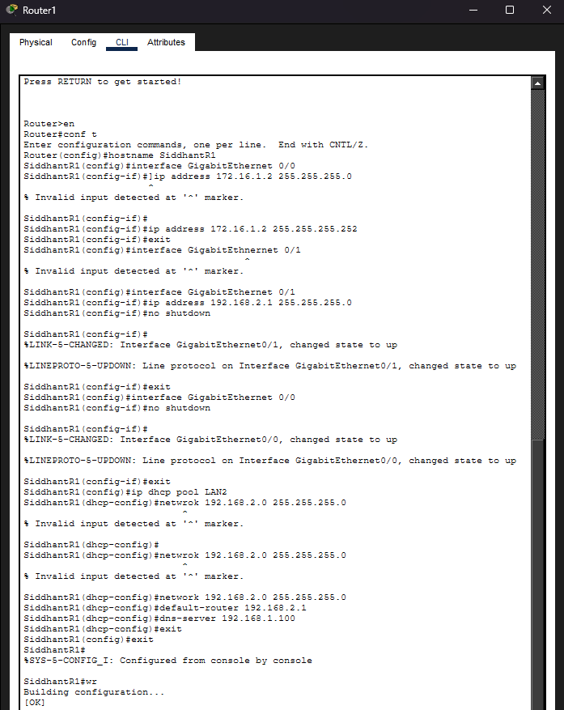

7) Create Router1's DHCP pool
Set up a DHCP pool for the LAN2 subnet the same way as on SiddhantR0, pointing DNS to the server on LAN1:
SiddhantR1(config)#ip dhcp pool LAN2
SiddhantR1(dhcp-config)#network 192.168.2.0 255.255.255.0
SiddhantR1(dhcp-config)#default-router 192.168.2.1
SiddhantR1(dhcp-config)#dns-server 192.168.1.100
SiddhantR1(dhcp-config)#exit

Output:

8) Enable RIP on Router1
Advertise SiddhantR1’s directly connected networks under RIP version 2 and save the configuration:
SiddhantR1(config)#router rip
SiddhantR1(config-router)#version 2
SiddhantR1(config-router)#network 172.16.1.0
SiddhantR1(config-router)#network 192.168.2.0
SiddhantR1(config-router)#exit
SiddhantR1(config)#exit
SiddhantR1#wr

Output:
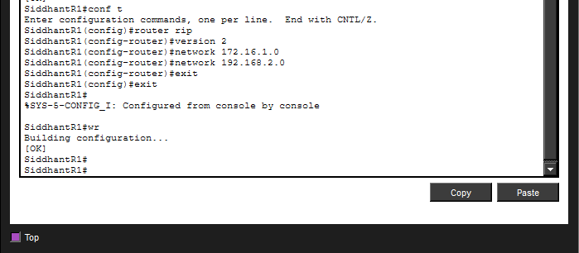

9) Verify DHCP is reaching PC1 and Laptop1
Confirm PC1 and Laptop1 automatically receive an address, gateway, and DNS server from the 192.168.2.0/24 pool via DHCP.

Output:
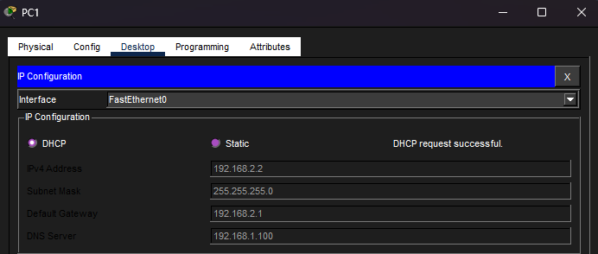
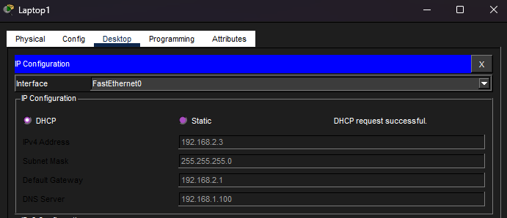

10) Add the server and prepare for service configuration
With RIP converged between SiddhantR0 and SiddhantR1, attach Server0 to Switch0 on LAN1, which will host DNS, HTTP, and Email services for both LANs.

Output:
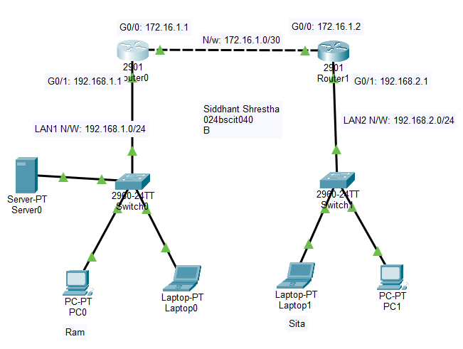

11) Configure Server0's IP addressing
Open Server0 → Desktop → IP Configuration, select Static, and assign it an address on LAN1 along with the gateway and its own address as DNS server:

Output:
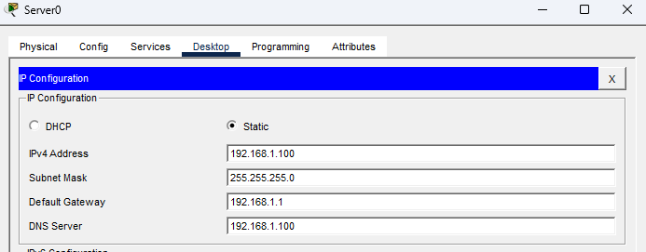

12) Configure the DNS service
On Server0's Services tab, open DNS, turn the service On, and add an A record mapping the domain name sxc.edu.np to the server's own IP address (192.168.1.100):

Output:
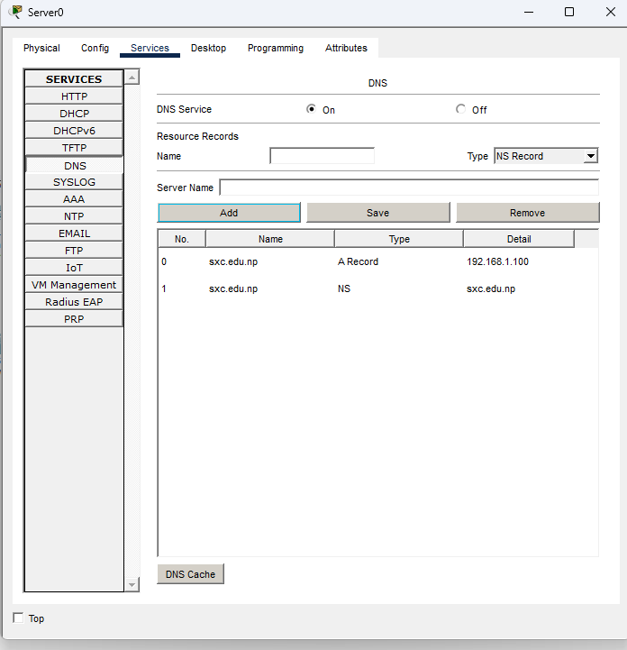

13) Configure the HTTP service
Open the HTTP service tab and edit the default index.html page so it serves custom welcome content when a client browses to the server's domain name.

Output:
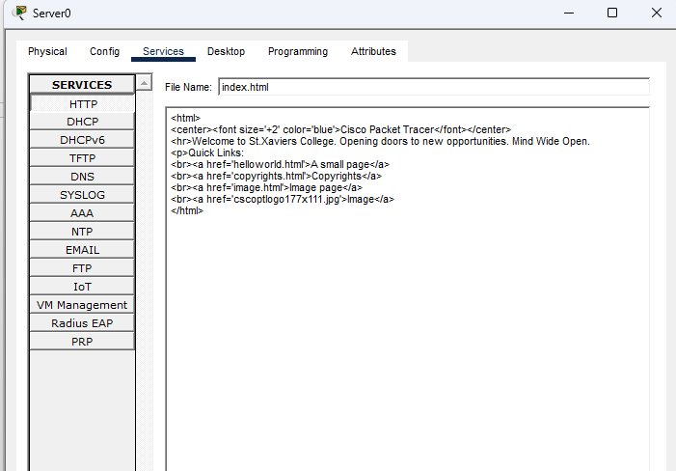

14) Test web access from PC0
Open PC0's web browser and enter http://sxc.edu.np. DNS resolves the name to the server's IP address and the configured page loads successfully.

Output:
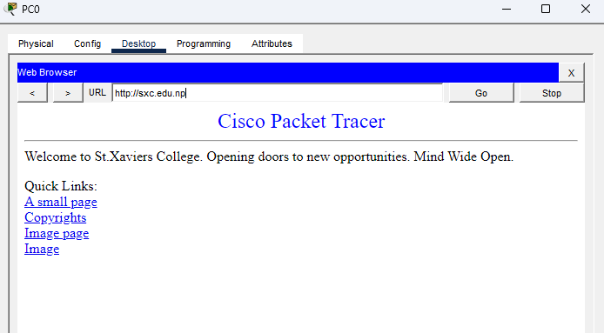

15) Test web access from Laptop0
Repeat the same browser test from Laptop0 on LAN1 to confirm the page loads consistently for every host on the local subnet.

Output:
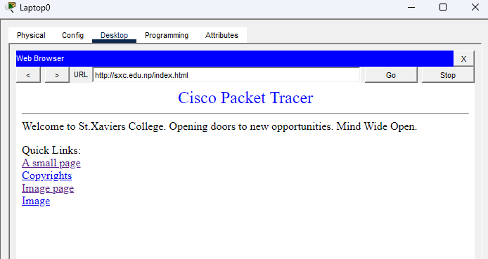

16) Test web access from PC1 (across the RIP-routed link)
From PC1 on LAN2, browse to http://sxc.edu.np. Successfully loading the page confirms that DNS resolution and HTTP traffic are both correctly routed across the RIP-learned path between the two LANs.

Output:
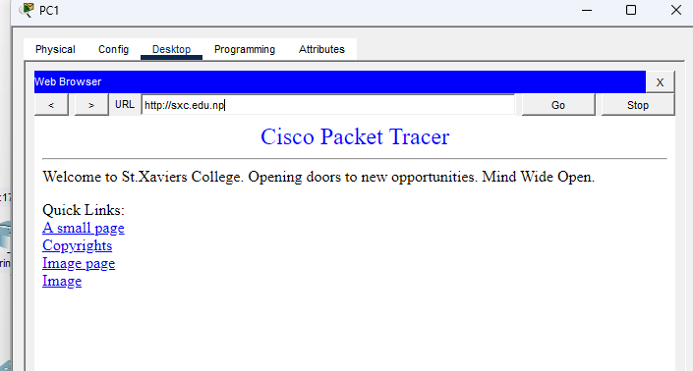

17)Configure the Email service
On Server0's Services tab, open EMAIL, turn SMTP and POP3 On, set the domain name to sxc.edu.np, and create two mailbox users, RAM and SITA, one per LAN:

Output:
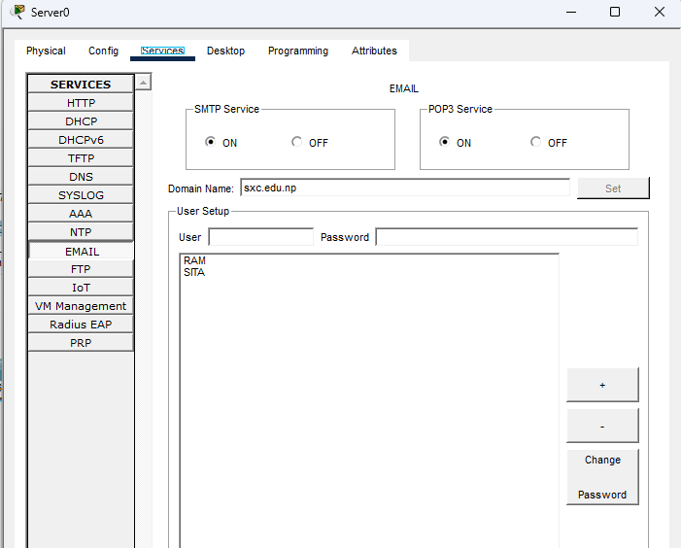

18)Configure the mail client on PC0
Open PC0's Desktop → E-Mail, and configure the user's name, email address (ram@sxc.edu.np), incoming/outgoing mail server (sxc.edu.np), and logon credentials for user RAM:

Output:
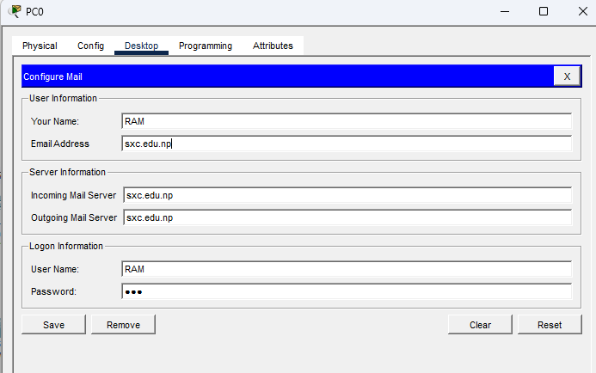

19)Configure the mail client on PC1
Repeat the same configuration on PC1 for user SITA, using the sita@sxc.edu.np mailbox and the same SMTP/POP3 server:

Output:
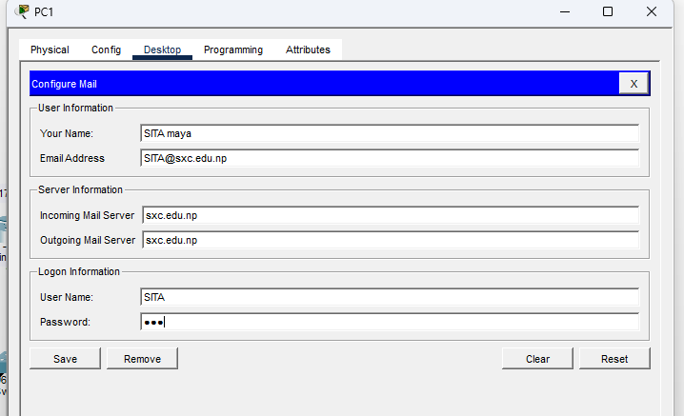

20) Send a test message
From PC1, compose a new mail addressed to ram@sxc.edu.np and send it:

Output:
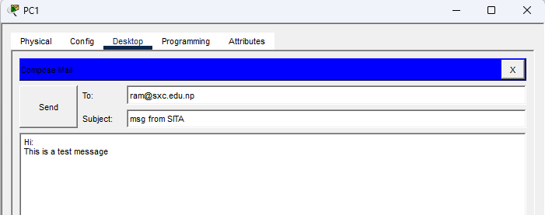

21) Receive the message on PC0
On PC0, open the mail browser and click Receive. The message from SITA arrives after the server resolves sxc.edu.np through DNS and delivers it over POP3:

Output:
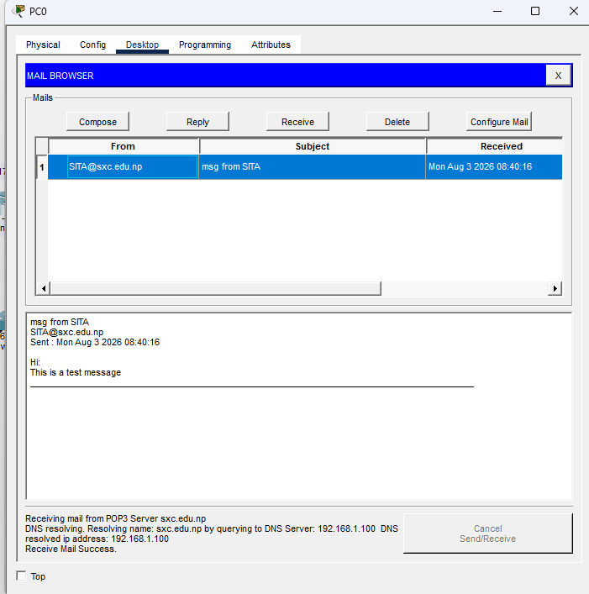

22) Reply from PC0
From PC0, reply to the message received from SITA:

Output:
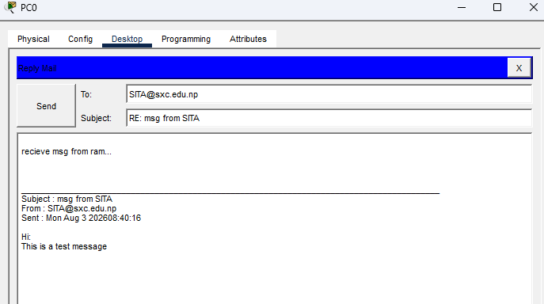

23) Receive the reply on PC1
Back on PC1, click Receive to confirm the reply from RAM arrives successfully, completing a full two-way exchange across the routed network:

Output:
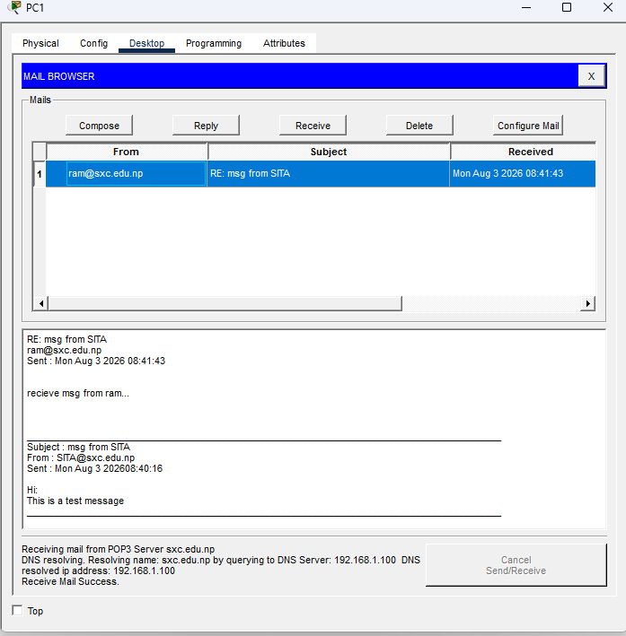

24)Verify with Simulation mode
Switch to Simulation mode and generate an HTTP or mail request from a LAN2 host toward the server on LAN1, then step through the event list to watch each packet cross Switch1, SiddhantR1, the inter-router link, SiddhantR0, and Switch0 before reaching the server, and the reply follow the same path in reverse.

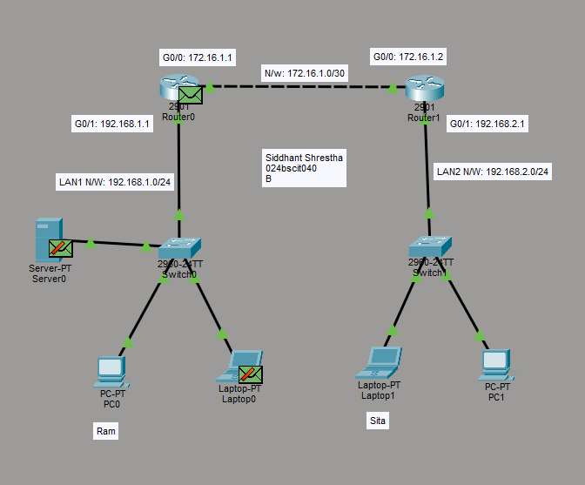
Output:
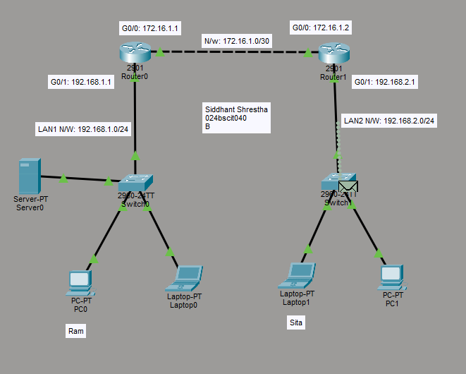
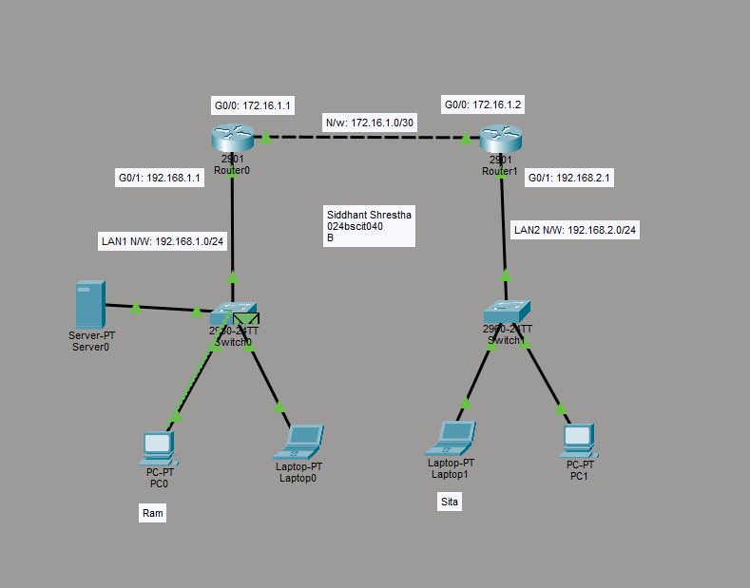
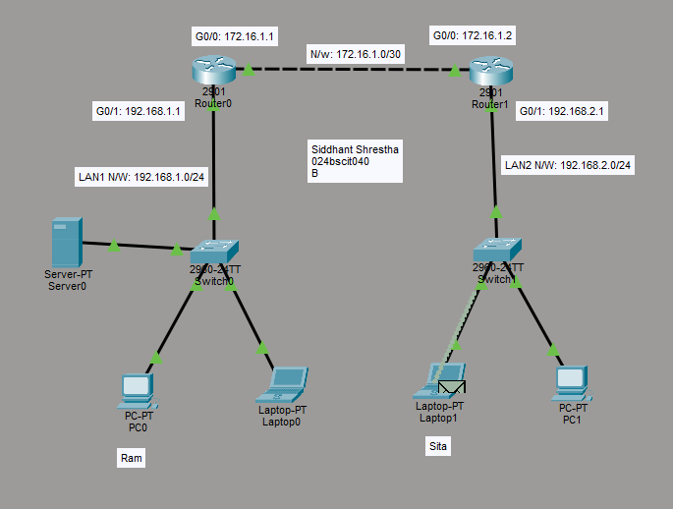
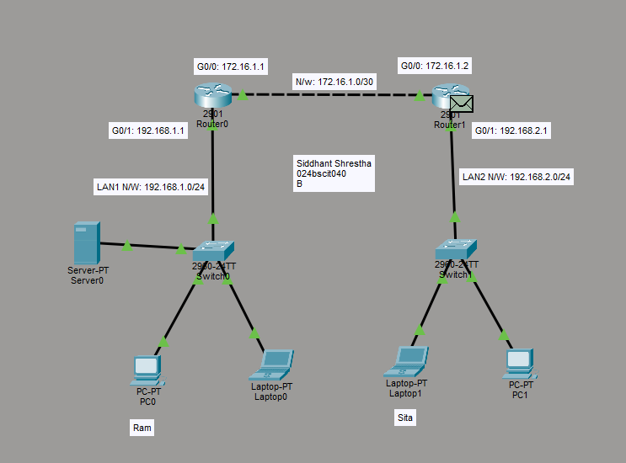

Conclusion:
This lab successfully integrated dynamic IP addressing, dynamic routing, and multiple application-layer services into a single functional network. By configuring DHCP on both routers, all PCs and laptops automatically received their IP addresses, default gateways, and DNS server information without requiring manual configuration. Similarly, enabling RIP version 2 on SiddhantR0 and SiddhantR1 allowed the routers to automatically exchange routing information and learn about each other’s LANs without the need for manually configured static routes.
The addition of DNS, HTTP, and email services demonstrated the importance of proper addressing and routing. After configuring the server’s A record and HTTP page, devices on both LAN1 and LAN2 were able to resolve sxc.edu.np and access the same webpage. Likewise, configuring SMTP, POP3, and individual mailbox accounts enabled users on different LANs to compose, send, receive, and reply to emails through the RIP-routed connection. Observing the communication in Simulation mode provided a packet-by-packet view of the process and confirmed that DHCP, RIP, DNS, HTTP, and email services were operating together correctly across the network.

